7.1.2.4 Packet Tracer – Configuring Basic EIGRP with IPv4
Addressing Table
Device | Interface | IPv4 Address | Subnet Mask
 |  | IPv6 Address/Prefix
IPv4-Edge | S0/0/0 | 172.31.6.1 | 255.255.255.0
 | S0/0/1 | 172.31.7.1 | 255.255.255.0
 | S0/1/0 | 209.165.200.226 | 255.255.255.224
Branch-1 | G0/0 | 172.31.8.1 | 255.255.255.0
 | S0/0/0 | 172.31.6.2 | 255.255.255.0
Branch-2 | G0/0 | 172.31.9.1 | 255.255.255.0
 | S0/0/1 | 172.31.7.2 | 255.255.255.0
IPv6-Edge | S0/0/0 | 2001:DB8:ACAD:7::1/64
 | S0/0/1 | 2001:DB8:ACAD:6::1/64
 | S0/1/0 | 2001:DB8:CAFE:ABCD::2/164
Branch-3 | G0/0 | 2001:DB8:ACAD:8::1/64
 | S0/0/0 | 2001:DB8:ACAD:7::2/64
Branch-4 | G0/0 | 2001:DB8:ACAD:9::1/64
 | S0/0/1 | 2001:DB8:ACAD:6:::2/64

Objectives
- Part 1: Propagate an IPv4 Default Route
- Part 2: Propagate an IPv6 Default Route
- Part 3: Verify Connectivity to Outside Hosts

Scenario
In this activity, you will configure and propagate a default route in EIGRP for IPv4 and IPv6 networks. EIGRP is already configured. However, you are required to configure an IPv4 and an IPv6 default route. Then, you will configure the EIGRP routing process to propagate the default route to downstream EIGRP neighbors. Finally, you will verify the default routes by pinging hosts outside the EIGRP routing domain.

Part 1: Propagate a Default Route in EIGRP for IPv4

Step 1: Verify EIGRP configuration on each IPv4 enabled router.
Display the routing table of each IPv4 enabled router and verify that all IPv4 routes are visible.

Branch-1 | 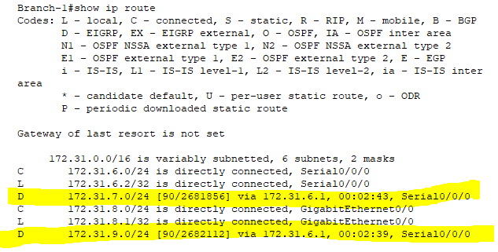
Branch-2 | 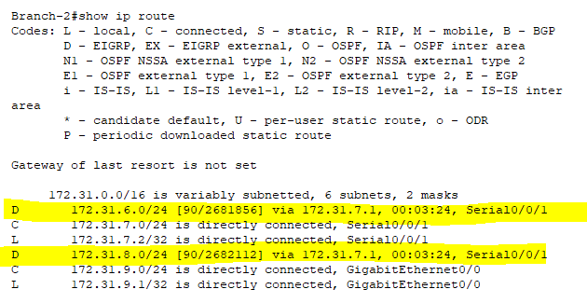
IPv4-Edge | 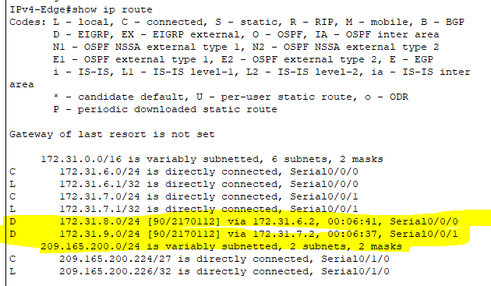

Step 2: Configure an IPv4 default route.
Configure a directly connected IPv4 default route on IPv4-Edge.

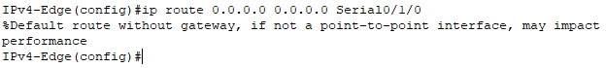

Step 3: Propagate the default route in EIGRP.
Configure the EIGRP routing process to propagate the default route.

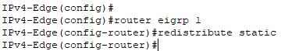

Step 4: Verify IPv4 default route is propagating.
Display the routing tables for Branch-1 and Branch-2 to verify the default route is now installed.

Branch-1 | 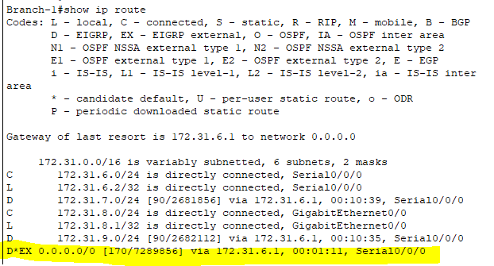
Branch-2 | 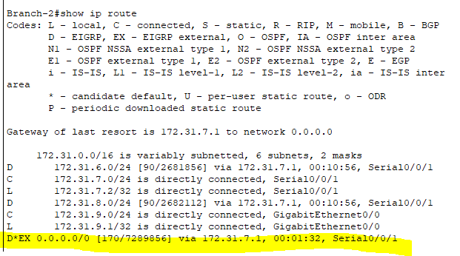
IPv4-Edge | 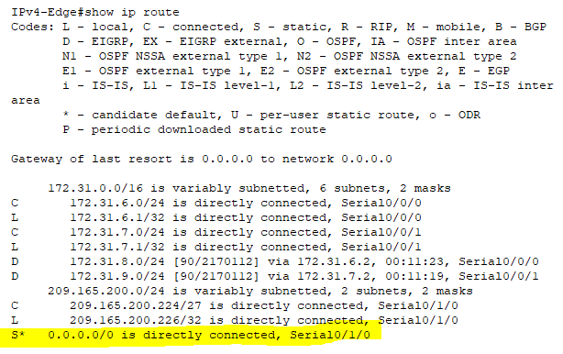

Part 2: Propagate a Default Route in EIGRP for IPv6

Step 1: Verify EIGRP configuration on each IPv6 enabled router.
Display the routing table of each IPv6 enabled router and verify that all IPv6 routes are visible.

Branch-3 | 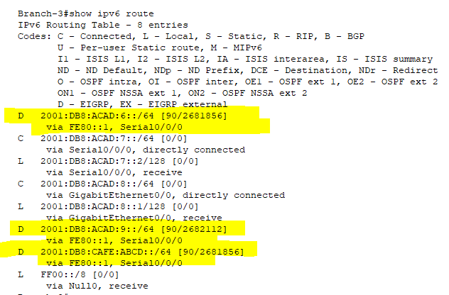
Branch-4 | 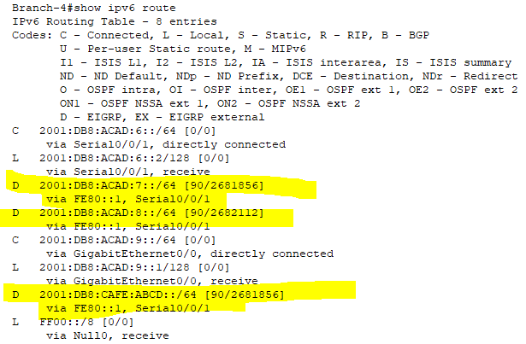
IPv6-Edge | 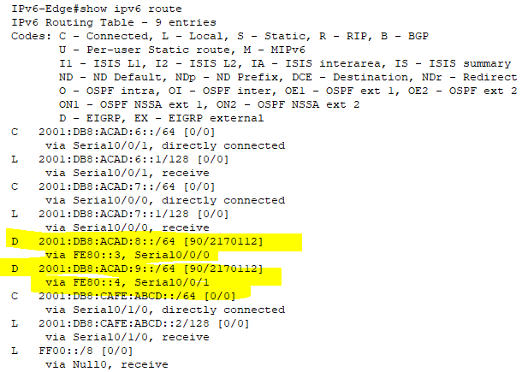

Step 2: Configure an IPv6 default route.
Configure a directly connected IPv6 default route on IPv6-Edge.

IPv6-Edge

Step 3: Propagate the default route in EIGRP.
Configure the EIGRP routing process to propagate the default route.

IPv6-Edge | 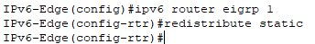

Step 4: Verify IPv6 default route is propagating.
Display the routing tables for Branch-3 and Branch-4 to verify the default route is now installed.

Branch-3 | 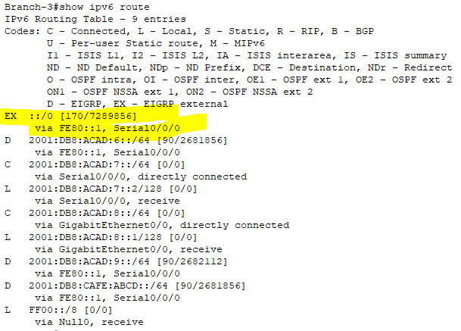
Branch-4 | 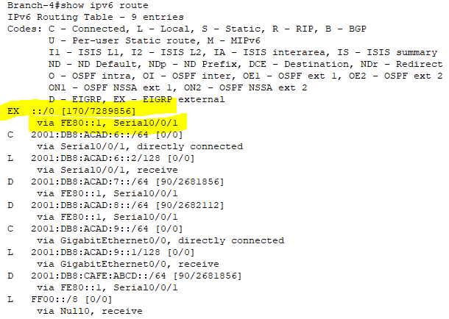
IPv6-Edge | 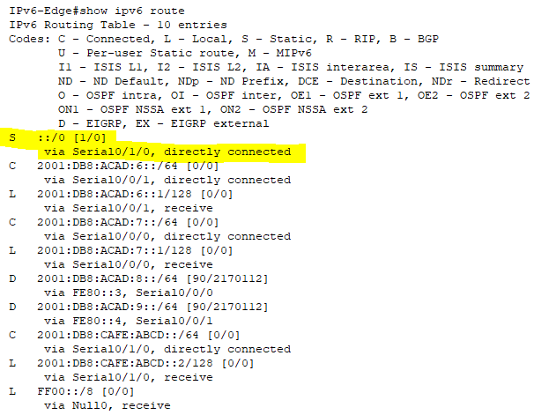

Part 3: Verify Connectivity to Outside Hosts
- PC1 and PC2 should now be able to ping IPv4 Outside Host.

PC1 Ping IPv4 Outside Host | 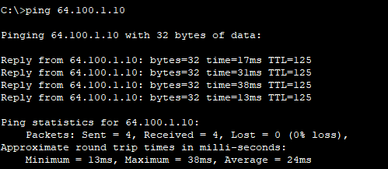
PC2 Ping IPv4 Outside Host | 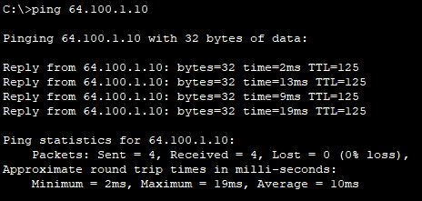

- PC3 and PC4 should now be able to ping IPv6 Outside Host.

PC3 Ping IPv6 Outside Host | 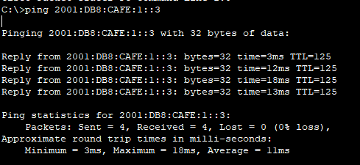
PC3 Ping IPv6 Outside Host | 